IT Training and Support Prospectus
SCW (South, Central and West) Digital, Data and Technology
ICB (Integrated Care Boards) Corporate 2023-2024

Document Control

Whilst this document may be printed, the electronic version is the controlled copy, and we would strongly advise that, wherever possible, you use the electronic version of this document.

Any printed copies of this document may have passed out of control and should be checked for accuracy and validity. The content of this document is correct at the time of writing.

The IT Training Team is committed to meeting the ambitious Net Zero Carbon NHS targets and supporting our NHS Customers to do the same. See SCW’s Green Plan - Green Plan - NHS SCW Support and Transformation for Health and Care (scwcsu.nhs.uk)

Contents
Welcome 5
What training we deliver for corporate staff 5
Corporate training 5
How we deliver our training 5
The Learning Hub 6
My Learning Record 6
e-Learning 6
Recorded webinars and videos 7
Three ways to book your training session 8
Live training sessions and webinars via MS Teams 8
IT training support available Mon-Fri, 9am – 5pm 9
Getting ready for your Online Training Session 10
New Starter training 12
Primary Care IT Induction (PCITI) 12
An Insight into General Practice Webinar 13
Data Quality training programme 14
Introduction to Medical Terminology Part 1 – Bodies, Bones and Basic Terms 14
Introduction to Medical Terminology Part 2 – Decoding the Doctor’s Dictionary 15
National and Spine Applications training programme 16
Electronic Referral Service (eRS) Provider services 16
Introduction to the NHS App 17
SMS Fragments Optimisation and Best Practice 18
N365 Productivity Apps 19
N365 Apps – live webinars and recordings 19
MS Forms 20
Microsoft Planner 21
Microsoft To Do 22
Microsoft Whiteboard 23
Microsoft Lists 24
Microsoft Sway 25
Microsoft Delve 26
Microsoft OneNote 27
MS Teams – Getting Started 28
MS Teams – Back to Basics 29
MS Teams - Meetings 30
MS Teams - Collaborative Working 31
IT Skills Pathway 31
Microsoft Office one-off Webinars via MS Teams 32

Welcome
This prospectus provides a guide to the IT training and other related services and resources we offer our customers in Primary healthcare. Our experienced and professional IT training and support team deliver comprehensive clinical and non-clinical systems training and support, systems optimisation, and data quality services.

What training we deliver for corporate staff
For the purpose of this document, corporate refers to staff employed or functioning within ICBs (Integrated Care Boards), PCNs (Primary Care Networks) or SCW

- Microsoft N365 end-user training and support
- New starter introduction and overview to General Practice IT
- Data quality services, including Medical Terminology
- Clinical systems training where required.
- NHS National systems and Spine applications (eRS, eRD, ePS, GP2GP) training and support
- Support with third-party software, e.g., Ardens, AccuRx, Docman, etc.

Corporate training
The IT training programme for 2023/24 is provided by the ICB alongside the GP IT offering, which has days purchased to deliver training, and as such, there is no charge at the point of training.

How we deliver our training
- Live online | - Face-to-face (on request)
- Webinars | - e-Learning
- Videos | - User guides
- Quick reference guides | - Telephone support

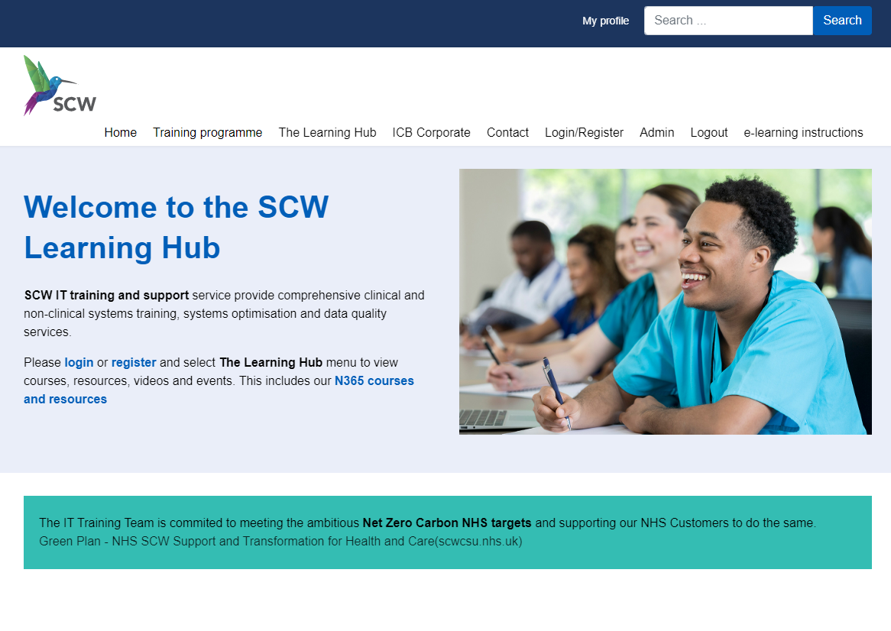
The Learning Hub

To find out more about who we are and what we do, go to The Learning Hub https://training.scwcsu.nhs.uk/

Our team provide comprehensive clinical and non-clinical systems training, systems optimisation, and data quality services.

Please login or register and select The Learning Hub menu to view courses, videos, and events. This includes our N365 courses and resources.

My Learning Record

The Learning Hub provides registered users with their own personal learning account, ‘My Learning Record,’ enabling them to keep track of courses they have attended and courses they are booked onto, as well as a record of the progress they have made with the e-Learning they have enrolled on. To find out more about your own Learning Record, log in to the Learning Hub, go to the Learning Hub menu, and then select My Learning Record.

e-Learning
We now offer e-Learning for a variety of topics via our Learning Management System (LMS) on The Learning Hub, alongside our live training. Just login to The Learning Hub, and you are ready to go!
Why use e-Learning?
- Convenience - available any time, no need to book or worry about joining a Teams meeting
- Users can learn at their own pace and repeat key content to reinforce learning

- Courses take approximately 2 hours to complete and are broken down into bite-sized modules, taking between 2-10 minutes
- Users can keep track of their e-Learning progress, see which content they have already completed, skip content they are familiar with, and go back for a refresher
To see what e-Learning courses we have, go to The Learning Hub, Courses & Resources, and look for the e-Learning tiles in each category.

Recorded webinars and videos
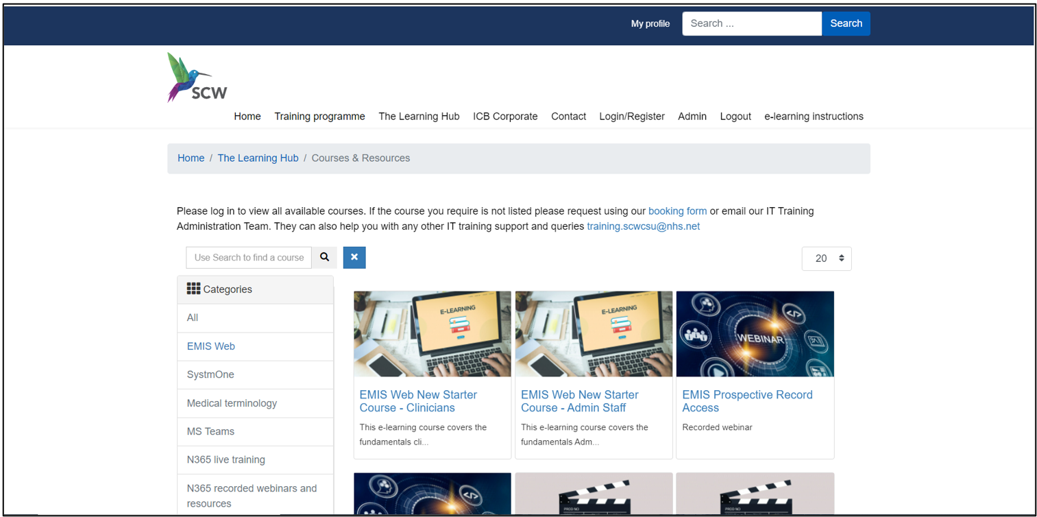

We have an extensive selection of short training videos and recorded webinars available on The Learning Hub to view at a time convenient to you. Topics are wide-ranging, from searching for a patient to concepts and protocols, and all our videos are accessible from any location.
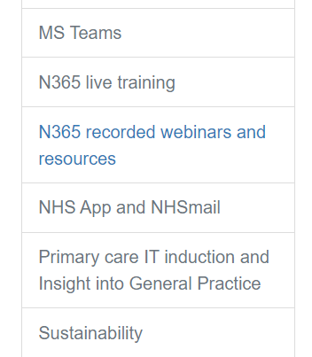
Go to The Learning Hub, Courses & Resources, then search by category and look for the recorded webinar tile:

Three ways to book your training session

- Email our Admin team at training.scwcsu@nhs.net with your request
- Visit The Learning Hub http://training.scwcsu.nhs.uk/ and use the Course Booking Form
- Call our Admin team on 0300 561 2828, 8:30am to 4:30pm, Monday to Friday

For most training enquiries, it would be helpful if you could include the following information:
- Topic(s) required

For each attendee:
- Name, email, and role
- Start date if a new member
- Working pattern, if not full-time

Our friendly team will be able to advise you on what training is available and help you identify the training that best suits your requirements.

Live training sessions and webinars via MS Teams
For most of our live training and all our webinars, we are using MS Teams. Session length varies depending on the subject.

Our live webinar sessions cover specific subjects, including the N365 productivity app, and are available to all our customers. Live webinar sessions last approximately 45 minutes to 1 hour, and attendees can ask questions as part of the demonstrations. Many of the live webinar sessions we offer have a recording posted on The Learning Hub.

Please let us know if you would like us to deliver any of our training face-to-face – in most cases, where we can, we will be happy to do so!

IT training support available Mon-Fri, 9am – 5pm

To request IT training support:

- Send an email any time to our Admin team at training.scwcsu@nhs.net with your query, including the best way to contact you

- Call our Admin team on 0300 561 2828, 8:30am to 4:30pm, Monday to Friday, with your query - there is usually a trainer available to deal with your query from 9am to 5pm

As well as pre-booked training, we also provide direct one-to-one telephone and virtual support for ad hoc queries and training needs. This service is available during office hours, and your call will be assigned to one of our experienced trainers, who will contact you directly to assist.

Getting ready for your Online Training Session
To ensure that the training can take place and to help make the most of your session, please follow these steps:

- Open your Outlook or NHS Mail portal and accept the calendar appointment for the booking, which contains an MS Teams link
- If possible, ensure that you will have somewhere quiet and undisturbed for the training session and check that the PC (Personal computers) (or laptop) has a working internet connection and (if required) access to the clinical system being trained
- For the best learning experience, to access MS Teams audio, we recommend you use a headset (or mobile phone earpiece) connected to your PC/laptop, where at all possible. However, you should still be able to use the audio/microphone built into your PC/laptop. Alternatively, you could use a desk phone to call the number in the calendar appointment – please let our Admin team know or make the trainer aware if you are having problems accessing sound or using your microphone
- In advance of the training, check that you are correctly logged in to the desktop (App) version of MS Teams (please see instructions below) and make a test call (see next step)
- Click the ellipsis (…) next to your Profile image/initials (top right-hand corner) and choose Settings > Device > Make a test call
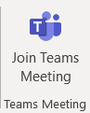
On the day of training, preferably a few minutes before, click on the link to join the Teams meeting or select the Join Teams Meeting button from the ribbon (if you are using your Outlook calendar)

Making sure you are signed-in to MS Teams Desktop App (NOT using a Browser)
- If you do not have a Teams icon on your desktop, please contact your IT support for installation – we do not recommend you use a browser to access our live online training
- If you are already in Teams, click your Profile in the top right-hand corner and select Sign out
- Double-click the Teams icon on your desktop (if it does not auto-start)
- Teams may try to use your Windows account to sign in with – please ensure you use your NHS Mail email address – this is the email address with @nhs.net at the end
- Click Sign in and enter your NHS Mail password
- If it is requested (i.e. if you have MFA (Multi Factor Authentication) enabled), enter the 6-digit code sent to you by text or email
- You will now be correctly signed-in to MS Teams and will be able to use the full Teams functionality as part of your live online training experience!

How to share your screen during the training session (where appropriate)
Your Teams toolbar is usually at the top right corner of your Teams screen, but if you have the older version of Teams, it will be at the bottom centre of your Teams screen, and you might need to ‘wiggle’ your mouse to view it.
- Click the Screen Sharing icon in your Teams toolbar (the icon looks like a rectangle with an arrow in it – there have been a number of changes to the design!)
- Your Teams screen will display your sharing options on the right-hand side
- Select the Screen option, NOT the Window option
- You will now be sharing whatever program you have on that screen (and can move anything across from one screen to another if you have more than one)

Please contact our Admin Team if you have any questions or need any help ahead of training, including the option of a short test call with the duty trainer

New Starter training

Primary Care IT Induction (PCITI)

Method of Delivery
Live webinar via MS Teams

Duration
1 hour

Who is this course for?
PCN (Primary Care Networks) staff who will primarily be based in GP practices.

Aim
To provide an overview of Primary Care and how IT is used in GP surgeries

Learning Objectives / Outcomes
At the end of the session, learners will be able to:
- Know when and why the NHS was created
- Identify the three core levels of care
- Understand how IT systems contribute towards patient safety and care
- Recognise the key process of the GP2GP transfer and registering new patients

An Insight into General Practice Webinar

Method of Delivery
Live Webinar via MS Teams

Duration
1 ½ hours

Who is this course for?
ICB & CSU (Commissioning Support Units) staff and non-practice based PCN staff

Aim
To increase the learners’ knowledge and understanding of the inner workings of General Practice

Learning Objectives / Outcomes
At the end of the session, learners will be able to understand:
- How a GP partnership works
- What a typical General Practice staff structure looks like
- What is involved in a selection of General Practice roles
- The ways in which practices receive funding
- What General Practice Clinical Systems look like
- How a variety of practice processes match to patient requirements

Data Quality training programme

Introduction to Medical Terminology Part 1 – Bodies, Bones and Basic Terms

Method of Delivery
Pre-booked live training via MS Teams

Duration
2 hours or by agreement; may require more than one session

Who is this training for?
Non-clinical members of staff, including new starters, who would like to better understand the terminology used in medical records

Aim
To provide an introduction to medical terminology, including bodies, bones, and basic terms.

Learning Objectives / Outcomes – at the end of the session, learners will be able to:
- Identify the main organs of the human body
- Recognise abbreviations and acronyms and describe their dangers when misused or misunderstood
- Recognise common terms used in the language of healthcare in general practice
- Identify the main bones in the human body

Introduction to Medical Terminology Part 2 – Decoding the Doctor’s Dictionary

Method of Delivery
Pre-booked live training via MS Teams

Duration
2 hours or by agreement; may require more than one session

Who is this training for?
Non-clinical members of staff, including new starters, who would like to better understand the terminology used in medical records

Aim
To provide an introduction to Medical Terminology and help ‘decode’ some of the terminology commonly used by clinicians in a patient’s record.

Learning Objectives / Outcomes – at the end of the session, learners will be able to:
- Define what we mean by ‘medical terminology’
- Look at the different ways medical terms are expressed
- Break down medical words into their component parts
- Translate medical terms into everyday language
- Use techniques to remember what each of these word parts mean

National and Spine Applications training programme

Electronic Referral Service (eRS) Provider services

SCW has assisted ICBs with the creation of provider services on the NHS e-referrals platform, both for GP with Special Interest programs and to reduce waiting times.

This has included training, configuration, and process mapping.
We can work with GP providers and private providers to set the services up, as well as supporting commissioners with commissioning the services on eRS.

By arrangement and usually commissioned at an additional fee.

Method of Delivery
Pre-booked live training via MS Teams

Duration
As required, but typically:

- Half a day to scope the service
- Half a day to create materials
- 2 hours per site to assist with the set-up of the service.
- Follow-up training and support available if required.

Learning Objectives / Outcomes for providers– at the end of the session, learners will be able to:
- Create and edit a workgroup.
- Create a service.
- Manage and edit a service.
- Identify different services and have a better insight into the eRS Portal.

Learning Objectives / Outcomes for Commissioners -objectives may include:
- Commissioning a service on the eRS portal
- Locating and recommissioning services on the eRS portal
- Understanding the scope and requirements for commissioning a new service.

Introduction to the NHS App

Method of Delivery
Live webinar via MS Teams

Duration
30 minutes

Who is this course for?
Anyone who would like to understand how the NHS app supports general practice and patients

Aim
To give an overview of the NHS App, as a simple and secure way to access a range of NHS services on your smartphone or web browser

Learning Objectives / Outcomes – at the end of the session, learners will be able to:
- Appreciate what the NHS App offers to patients
- Know how the NHS App benefits patients and the practice
- Understand how to access the App
- Know how to make Every contact count when promoting the App
- Have an awareness of the Secure Messaging Service (SMS) the App offers

SMS Fragments Optimisation and Best Practice

Method of Delivery
Live webinar via MS Teams

Duration
30 minutes

Who is this course for?
Anyone who sends SMS messages to patients from within the clinical systems.

Aim
To give a better understanding of the impact of message length on the eventual cost to the NHS.
It will also explain how to optimise the use of SMS messaging whilst reducing the cost due to multiple fragments and failed messages.

Learning Objectives / Outcomes – at the end of the session, learners will be able to understand:

- What a fragment is and how it is charged
- How reducing the number of fragments can help save costs
- How to reduce the number of fragments
- Alternatives to SMS messaging
- Where to go for further support and guidance

N365 Productivity Apps
Below is a list of the Apps that the IT training team currently supports, but as your organisation moves into the next phase of its development with N365, more will come on board for use, and our team will endeavour to provide end user training and support for these, where this has been agreed.

N365 Apps – live webinars and recordings

Delivered via MS Teams, these webinars are an introduction to the new N365 Apps. These are bookable from the Learning Hub, where you can select the required topic to see further information on what is covered in the webinar and book your place if required. A recorded version of each of these webinars is available on The Learning Hub.

MS Forms

Method of Delivery
Live webinar via MS Teams.
Prerecorded webinars via our Training website

Duration
1.5 hrs

Who is this course for?
- Anyone who wishes to create surveys and quizzes, collect and analyse responses and present the data effectively

Aim
To give users a basic introduction to using Microsoft Forms, including
- What is Forms, and how do I access it?​
- Adding Questions to Surveys​
- Sharing Surveys with a range of different users​
- Responding & Analysing Results​
- Quizzes: how do they differ from Surveys?

Learning Objectives / Outcomes – content is flexible, but at the end of the session, learners will have looked at content that can include, but is not limited to:
- Understand what Forms is and how to access it
- Be able to build a Survey or Quiz
- Understand how to share Forms with different types of users
- Be able to analyse Survey responses

Microsoft Planner

Method of Delivery
Live webinar via MS Teams.
Prerecorded webinars via our Training website

Duration
1 hr

Who is this course for?
- Anyone who wishes to create and work with plans in Microsoft Planner

Aim
To give users a basic introduction to using Microsoft Planner, including
- Planner Basics
- Creating a new Plan
- Working with Plans

Learning Objectives / Outcomes – content is flexible, but at the end of the session, learners will have looked at content that can include, but is not limited to:
- Identify appropriate uses for Planner
- Create a Plan for a new project
- Work with tasks within an existing Plan

Microsoft To Do
Method of Delivery
Prerecorded webinar via our Training website only

Duration
20 minutes

Who is this course for?
Anyone who would like to better organise their workday
Aim
To give users a basic introduction to using Microsoft To Do to bring together their work from the Microsoft suite of apps.

Learning Objectives / Outcomes – content is flexible, but at the end of the session, learners will have looked at content that can include, but is not limited to:
- Locate To Do in their list of Apps.
- Add items to their personal daily planner from multiple sources.
- Complete tasks in the daily planner.
- Identify key differences between Planner and To Do

Microsoft Whiteboard

Methods of Delivery
Live webinar via MS Teams.
Prerecorded webinars via our Training website

Duration
1 hr

Who is this course for?
- Anyone who wishes to use Whiteboard in a Teams meeting

Aim
To give users a basic introduction to using Microsoft Whiteboard, including
- Whiteboard functions​
- Whiteboard in Teams vs Whiteboard in the Web App (Edge)​
- Sharing a Whiteboard

Learning Objectives / Outcomes – content is flexible, but at the end of the session, learners will have looked at content that can include, but is not limited to:
- Be able to access the Whiteboard in a Teams meeting​
- Know how to make the most of Whiteboard functionality​
- Know how to access and use Whiteboard via Edge​
- Understand how to share a Whiteboard from Edge

Microsoft Lists

Methods of Delivery
Live webinar via MS Teams.
Prerecorded webinars via our Training website

Duration
1 hr

Who is this course for?
- Anyone who wishes to use Lists to log and track progress on a variety of activities. This might be a project, onboarding, stock control or complaints.

Aim
To give users a basic introduction to using Microsoft Lists, including
- What is Lists?
- Creating a List
- Modifying List data
- Formatting Lists

Learning Objectives / Outcomes – content is flexible, but at the end of the session, learners will have looked at content that can include, but is not limited to:
- Understand what a List is​
- Be able to create a List and add data to it

Microsoft Sway

Methods of Delivery
Live webinar via MS Teams.
Prerecorded webinars via our Training website

Duration
1 hr

Who is this course for?
- Anyone who wishes to use Sway to communicate information

Aim
To give users a basic introduction to using Microsoft Whiteboard, including
- What is Sway?​
- Building a Sway​
- Sharing a Sway​
- Changing Sway Design​
- Adding Video​
- Image Interactivity

Learning Objectives / Outcomes – content is flexible, but at the end of the session, learners will have looked at content that can include, but is not limited to:
- Understand what Sway is and how to start using it​
- Be able to start building a Sway​
- Understand how to share and distribute your Sways

Microsoft Delve

Methods of Delivery
Live webinar via MS Teams.
Prerecorded webinars via our Training website

Duration
1 hr

Who is this course for?
- Anyone who wishes to use Delve to view and share documents.

Aim
To give users a basic introduction to using Microsoft Delve, including
- Overview of Delve
- Features of Delve
- Delve Quiz (for live session)

Learning Objectives / Outcomes – content is flexible, but at the end of the session, learners will have looked at content that can include, but is not limited to:
- What is Delve?
- View and update your Personal Profile
- View your documents
- Add Boards and Favourites
- Share documents
- Use the Search feature

Microsoft OneNote

Methods of Delivery
Live webinar via MS Teams.
Prerecorded webinars via our Training website

Duration
1 hr

Who is this course for?
- Anyone who wishes to explore using OneNote for personal note keeping.

Aim
To give users a basic introduction to using Microsoft OneNote, including
- Setting up OneNote
- Taking Notes
- Useful Extras

Learning Objectives / Outcomes – content is flexible, but at the end of the session, learners will have looked at content that can include, but is not limited to:
- Understand how to access OneNote
- Create and edit new Notes
- Make use of existing Tags and create new ones
- Change the page date and time
- Utilise the Email page, adding meeting details functions
- Build personalised page templates

MS Teams – Getting Started

Method of Delivery
Prerecorded webinars via our Training website only

Duration
30 minutes

Who is this course for?
Those new to using MS Teams

Aim
To give users a basic introduction to using Microsoft Teams for the purpose of communicating with NHS colleagues in their own and other NHS organisations

Learning Objectives / Outcomes –

- Login to MS Teams correctly and confirm they have used the correct login details
- Understand the benefits of logging in correctly
- Use Profile Status to indicate availability
- Attend a Teams meeting and use functionality appropriately, including:
  - Sound and cameras
  - Sharing screens
  - New functionality

MS Teams – Back to Basics

Method of Delivery
Live webinar via MS Teams – please visit The Learning Hub for details

Duration
1 hour

Who is this course for?
Anyone who wishes to use MS Teams to communicate effectively with colleagues within their own organisation, the wider NHS, and other external organisations

Aim
To give users a basic introduction to using Microsoft Teams for the purpose of communicating with NHS colleagues in their own and other NHS organisations

Learning Objectives / Outcomes – content is flexible, but at the end of the session, learners will have looked at content that can include, but is not limited to:
- Login to MS Teams correctly and confirm they have used the correct login details
- Understand the benefits of logging in correctly
- Use Profile Status to indicate availability
- Locate, understand, and use Settings and other functionality from their Profile
- Understand the difference between Teams and Channels
- Understand the difference between using Chat and Channel to reply to Posts
- Attend a Teams meeting and use functionality appropriately, including:
  - Sound and cameras
  - Sharing screens
  - New functionality

MS Teams - Meetings

Method of Delivery
Recording of the webinar is available on our website
Live webinar via MS Teams

Duration
1 hour

Who is this course for?
Anyone who wishes to use MS Teams to conduct meetings

Aim
To give users an introduction to using Microsoft Teams for organising, scheduling, running, and attending Live webinars via MS Teams meeting with NHS and non-NHS colleagues

Learning Objectives / Outcomes – at the end of the session, learners will be able to:
- Initiate an Ad hoc meeting in MS Teams
- Schedule and invite colleagues to an MS Teams meeting using an invitation from Outlook
- Understand the differences in meeting size (number of attendees) between Ad hoc, Outlook and Live Event meeting formats
- Understand the options available for bypassing the lobby when entering a Teams meeting
- Be familiar with and use functionality within a Teams meeting, e.g., mute, video, live captions, screen sharing, etc., to their best advantage

MS Teams - Collaborative Working

Method of Delivery
Recording of the webinar is available on our website
Live webinar via MS Teams

Duration
1 hour

Who is this course for?
Anyone who wishes to invite colleagues from organisations outside of the NHS to attend meetings and access other content in MS Teams

Aim
To give an overview of the collaborative options available for NHS and non-NHS staff in MS Teams

Learning Objectives / Outcomes – at the end of the session, learners will be able to:
- Understand the nature of guests and their access to the NHS Teams
- Invite Guests to a meeting via Outlook!
- Understand the Guest process for Chat, Teams, and Channels
- Be familiar with the functionality regarding document sharing in Teams

IT Skills Pathway

IT Skills Pathway is a free NHS on-line learning resource available to all NHS staff. Courses include:

- Windows
- Excel
- Word
- PowerPoint
- Outlook
- OneNote

The GP IT Training and Support Admin team at SCW provide an administrative function for the IT Skills Pathway. We can guide you to the course details and provide login details. For more information, please visit https://www.e-lfh.org.uk/programmes/it-skills-pathway/. The IT Skills Pathway also includes a knowledge base for Microsoft Office and Windows queries.

Microsoft Office one-off Webinars via MS Teams
If you would prefer one-to-one Microsoft Office training delivery, we can offer bespoke live webinar training on the following software:

- Excel:
  - Introduction – basic navigation, adding and editing data, formatting, basic formula
  - Intermediate – navigation hints and tips, filtering and sorting, pivot tables and charts
  - Advanced – logical and statistical functions, validation, conditional formatting
- Word:
  - Introduction – Adding and formatting text, printing, bulleted/numbered lists, reviewing
  - Intermediate – creating and editing tables, inserting graphics/pictures, mail-merge
- Outlook:
  - Basic email and inbox management, creating a signature, setting and Out of Office reply
  - Calendar views and sharing, creating calendar appointments / Teams meetings in Outlook
- PowerPoint:
  - Creating a slideshow, adding content, transition and animation effects, hints, and tips for presenting a slideshow, printing of slides for resources

Please note that this training is subject to availability - for more details, or if you would like to speak to us about the IT Skills Pathway, please contact our Admin Team training.scwcsu@nhs.net

